**ACKNOWLEDGEMENT**

I am greatly indebted to **Dr. Anitha G Pillai**, Principal, SCMS SCHOOL OF ENGINEERING AND TECHNOLOGY, Ernakulam and **Dr. Manish T I**, Head of department, Department of Computer Science and Engineering, SSET, who whole heartedly granted me the permission to do the project. I would like to thank my guide, **Ms.** **Sruthy K Joseph**, and project coordinator, **Dr. Deepa K**, Department of Computer Science and Engineering, SSET who has given me valuable guidance and support all the way. I would like to express my sincere gratitude to all the teachers of Computer Science Department who gave me moral and technical support. I would like to thank the supporting staff in the computer lab whose dedicated work kept the lab working smoothly, thus enabling me to have access to various resources which helped me understand more about the project topic. I would also like to thank friends and family members for providing me with necessary resources and support. Last but not the least, I would like to thank God Almighty for helping me to do my project hassle free.

**ABSTRACT**

The system utilizes web technology to combat food wastage and food poverty through a streamlined process. Donors register surplus food, and administrators coordinate with nearby agents for collection and delivery to orphanages or individuals in need. Web technology ensures efficient communication, and donors receive timely alerts upon successful donation receipt.This innovative approach not only addresses the critical issue of food wastage by redirecting surplus resources but also contributes to the targeted alleviation of food poverty. By merging technological efficiency with social responsibility, this system exemplifies a successful social innovation. It offers a scalable and sustainable solution to simultaneously reduce food wastage and support vulnerable populations, showcasing the transformative potential of web technology for positive societal change.

**TABLE OF CONTENTS**

**CONTENTS PAGE NO.**

Acknowledgement i

Abstract ii

[List of Tables](https://docs.google.com/document/d/1_00nqnj0ShN-fTNj_W9i2yCfnno48lgzeR6JpLq-vPQ/edit#heading=h.30j0zll)  v

[List of Figures](https://docs.google.com/document/d/1_00nqnj0ShN-fTNj_W9i2yCfnno48lgzeR6JpLq-vPQ/edit#heading=h.1fob9te) vi

[Chapter 1. Introduction](https://docs.google.com/document/d/1_00nqnj0ShN-fTNj_W9i2yCfnno48lgzeR6JpLq-vPQ/edit#heading=h.3znysh7)  1

1.1 [General Background](https://docs.google.com/document/d/1_00nqnj0ShN-fTNj_W9i2yCfnno48lgzeR6JpLq-vPQ/edit#heading=h.2s8eyo1)  1

1.2 [Objective 2](https://docs.google.com/document/d/1_00nqnj0ShN-fTNj_W9i2yCfnno48lgzeR6JpLq-vPQ/edit#heading=h.17dp8vu)

1.3 Scope 2

1.4 Organization of Report 3

Chapter 2. System Specifications 4

2.1 [Existing System](https://docs.google.com/document/d/1_00nqnj0ShN-fTNj_W9i2yCfnno48lgzeR6JpLq-vPQ/edit#heading=h.2s8eyo1)  4

2.2 Proposed System 4

2.3 Hardware Specification 4

2.4 Software Specification 5  
 2.5 Software tools &amp; Platforms 5

|  |  |
| --- | --- |
| Chapter 3. System Design 6 |  |
| 3.1. Introduction 6 |  |

|  |  |
| --- | --- |
| 3.2. Module Description 6 |  |
| 3.2.1. Admin Module 7 |  |
| 3.2.2. Donor Module 7  3.2.3. Agent Module 7 |  |
| 3.3. Data Flow Diagram 8  3.4. Database Design 11  3.5. Table Structure 12 |  |

Chapter 4. System Testing 14

4.1. Introduction 14

4.1.1. Unit Testing 14

4.1.2.Integration Testing 14

4.1.3.User Acceptance Tesing 15

4.2. Test Cases 15

Chapter 5. System Implementation and Maintenance 16

Chapter 6. Output Screenshots 18

Chapter 7. Conclusion and Future Scope 27

References vii

**LIST OF TABLES**

|  |  |  |
| --- | --- | --- |
| **No.** | **Title** | **Page No.** |
| 1. | Donor Table | 12 |
| 2. | Admin Table | 12 |
| 3. | Agent Table | 12 |
| 4. | Food donation Table | 13 |
| 5. | Feedback Table | 13 |
| 6. | Orphanage Table | 13 |

**LIST OF FIGURES**

|  |  |  |  |
| --- | --- | --- | --- |
| **No.** | **Title** |  | **Page No.** |
| 1. | Data Flow Diagrams |  | 8 |
| 2. | DFD Level 0 |  | 8 |
| 3. | DFD Level 1 |  | 8 |
| 4. | DFD Level 2 |  | 9 |
| 5. | Screenshots |  | 18 |

**CHAPTER-1**

**INTRODUCTION**

* 1. **GENERAL BACKGROUND**

In response to the dual challenges of food wastage and food poverty, this project introduces a web-based system designed to revolutionize the way surplus food is managed and distributed. The inspiration behind this initiative lies in recognizing the shortcomings of traditional food distribution systems and the untapped potential of technology to create a more efficient and impactful process.

The global scale of food wastage, coupled with persistent issues of hunger, underscores the need for a paradigm shift in resource management. The proposed system envisions a collaborative effort involving donors, administrators, and agents, all facilitated through a web-based platform. Donors contribute surplus food, administrators coordinate the collection and distribution processes, and agents ensure the seamless transfer of donations to those in need.

Key to the system's success is the integration of web technology, enabling real-time communication, efficient coordination, and transparent feedback. Donors receive immediate alerts upon successful donation receipt, fostering engagement and accountability.

By addressing both food wastage and food poverty, this project strives to be a socially innovative solution with the potential for widespread impact. It aligns with principles of sustainability, social responsibility, and technological innovation, presenting a scalable model adaptable to global challenges. The forthcoming project report will provide detailed insights into the system's architecture, functionality, and anticipated societal contributions.

* 1. **OBJECTIVE**

The primary objective of this project is to leverage web technology to create a streamlined system that addresses the dual challenges of food wastage and food poverty. By facilitating efficient communication and coordination between donors, administrators, and agents, the project aims to revolutionize the way surplus food is managed and distributed. The overarching goal is to contribute to a more sustainable and equitable food distribution system, reducing waste while ensuring that surplus resources reach those in need.

* 1. **SCOPE**

The project's scope is comprehensive, aiming to tackle the complex issues of food wastage and food poverty through the development of a web-based system. It involves active engagement from various stakeholders, including donors, administrators, and agents. The system's primary focus is on creating an efficient mechanism for the redistribution of surplus food, facilitated by real-time communication and coordination through web technology. An alert and notification system enhances donor engagement by providing timely feedback on the success of their contributions. The project is designed with geographic scalability in mind, ensuring adaptability to different locations and accommodating diverse user participation levels. Beyond its technical facets, the project aspires to make a positive social impact by addressing social responsibility and contributing to the equitable distribution of resources. Sustainability is a key consideration, and the project envisions a model that can be globally embraced, revolutionizing surplus food management and fostering positive societal change.

* 1. **ORGANIZATION OF REPORT**

The report on the Food Donation Management System follows a structured format, commencing with the Title Page and Abstract, providing a brief overview of project objectives and methodologies. A well-organized Table of Contents guides readers through sections including Introduction,Methodology, and System Design. Implementation details the practical aspects of system development, while Results and Discussion analyze project outcomes.The report concludes with a References section and Appendices for supplementary materials, ensuring a concise yet comprehensive presentation of the Food Donation Management System project.

**CHAPTER-2**

**SYSTEM SPECIFICATIONS**

**2.1 EXISTING SYSTEM**

The existing system for surplus food donation management relies on traditional, manual methods, often resulting in inefficiencies and food wastage. Coordination between donors, administrators, and distribution agents is challenging, hindering timely pickups and deliveries. Communication lacks a centralized platform, and donors may not receive immediate feedback. The system's limitations in scalability and adaptability highlight the need for an innovative, web-based solution to streamline surplus food redistribution, enhance communication, and maximize positive impact.

**2.2 PROPOSED SYSTEM**

The proposed system introduces a transformative approach to surplus food management, leveraging web technology to address inefficiencies in the existing system. It envisions a centralized platform where donors can seamlessly register and contribute surplus food, administrators can efficiently coordinate logistics, and agents can facilitate the timely collection and distribution of donations. The integration of web technology ensures real-time communication, providing donors with immediate feedback on the impact of their contributions. An alert and notification system enhances engagement and accountability. The proposed system's scalability and adaptability are key strengths, allowing it to cater to diverse geographic locations and varying levels of surplus food generation. Overall, the proposed system aims to revolutionize surplus food distribution, making it more efficient, transparent, and socially impactful.

**2.3.HARDWARE SPECIFICATIONS**

* Processor : Intel dual core
* Speed : 3.30GHz
* RAM : 2GB(min)
* Key board : Standard keyboard
* Mouse : Three button Mouse
* Monitor : LCD

**2.4.SOFTWARE SPECIFICATIONS**

* Operating System : Windows 7 or above
* Programming language : PHP
* Front end : HTML,CSS,Javascript
* Back end : MySQL
* Application server : WAMP

**2.5. SOFTWARE TOOLS &amp; PLATFORMS**

**Programming Languages**

* PHP
* HTML5
* CSS3
* JavaScript

**Database**

* MySQL

**Web server**

* + Apache

**Tools manager**

* + XAMPP

**CHAPTER**-**3**

**SYSTEM DESIGN**

**3.1 INTRODUCTION**

The system design phase is a pivotal stage in developing a surplus food management platform. It entails meticulous planning, structuring the architecture, and defining user roles. The focus is on creating an intuitive interface, integrating web technologies for real-time communication, and establishing a secure database schema. The design prioritizes user experience, ensuring seamless navigation and engagement for donors, administrators, and agents. Security measures are implemented to protect sensitive data, and an efficient notification system keeps users informed. This comprehensive blueprint guides the development team, setting the foundation for an impactful, user-friendly, and scalable surplus food management and distribution system.

**3.2 MODULE DESCRIPTION**

**3.2.1 Admin Module**

* User Management: Allows the admin to create,edit and manage user accounts,including donors and agents.
* Food Donation Management: Enables the admin to oversee the entire donation process,including accepting or rejecting donations,assigning agents and monitoring food inventory.
* Dashboard: Admin can view ongoing activities such as pending pickups, recent donations and system alerts.
* Donor Management: Admin has the ability to approve or reject donor registrations and have access to donor profiles and donation history.
* Agent Management: Admin can approve or reject agent registrations and can access to agent profiles and pickup history.
* Communication: Admin can communicate with donors and agents and provide automated notifications for important updates.

**3.2.2 Donor Module**

* Registration and Profile Management: Allows donors to create and manage their profiles including contact information and donation preferences.
* Food donation: Enables donors to input details of food donations,including type,quantity,expiration date and pickup availability.
* Donation Tracking: Can View the status of submitted donations and receives notifications on donation acceptance and pickup schedules.
* History and Feedback: Displays history of previous donations made by the donor and provides feedback on pickup experiences.

**3.2.3 Agent Module**

* Registration and Profile Management: Allows agents to create and manage their profiles including contact information and availability.
* Pickup Scheduling: Allows agents to schedule and manage the pickup and delivery of donated food.
* Confirmation and Feedback: Confirms successful
* pickups and provide feedback on the donation pickup process.
* Communication: Communicate with donors and admin regarding pickup details.

**3.3 DATA FLOW DIAGRAM**

**LEVEL 0:**

Figure 3.3 DFD of level 0

**LEVEL 1:**

Figure 3.4 DFD of level 1

**LEVEL 1.1:**

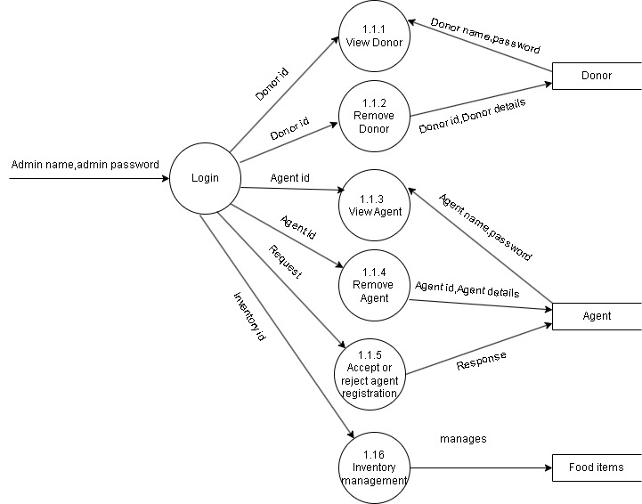

Figure 3.5 DFD of level 1.1

**LEVEL 1.2:**

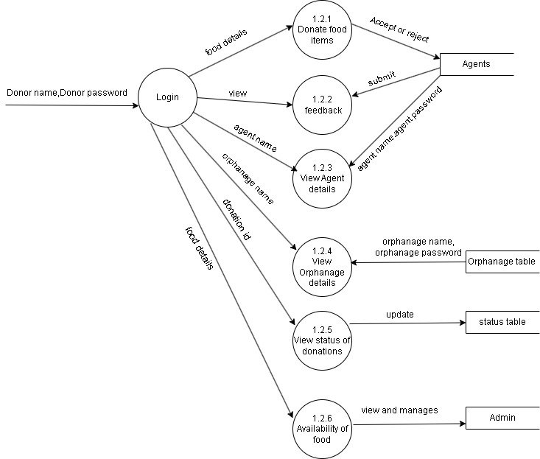

Figure 3.6 DFD of level 1.2

**LEVEL 1.3:**

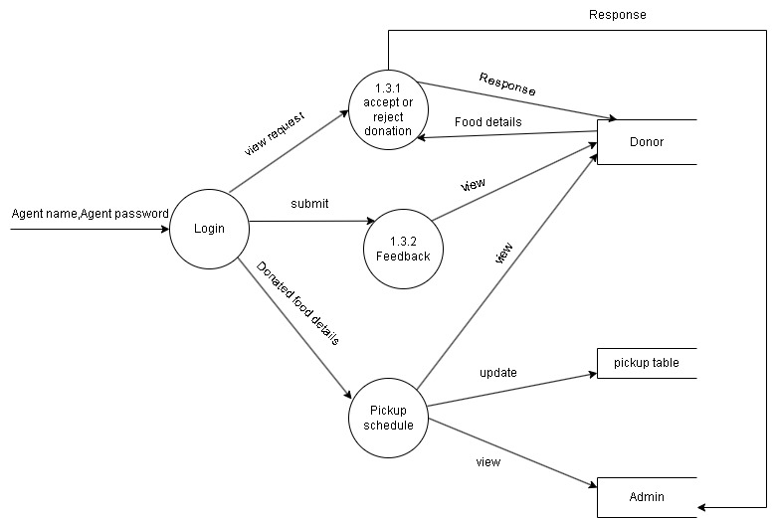

Figure 3.7 DFD of level 1.3

**3.4. DATABASE DESIGN**

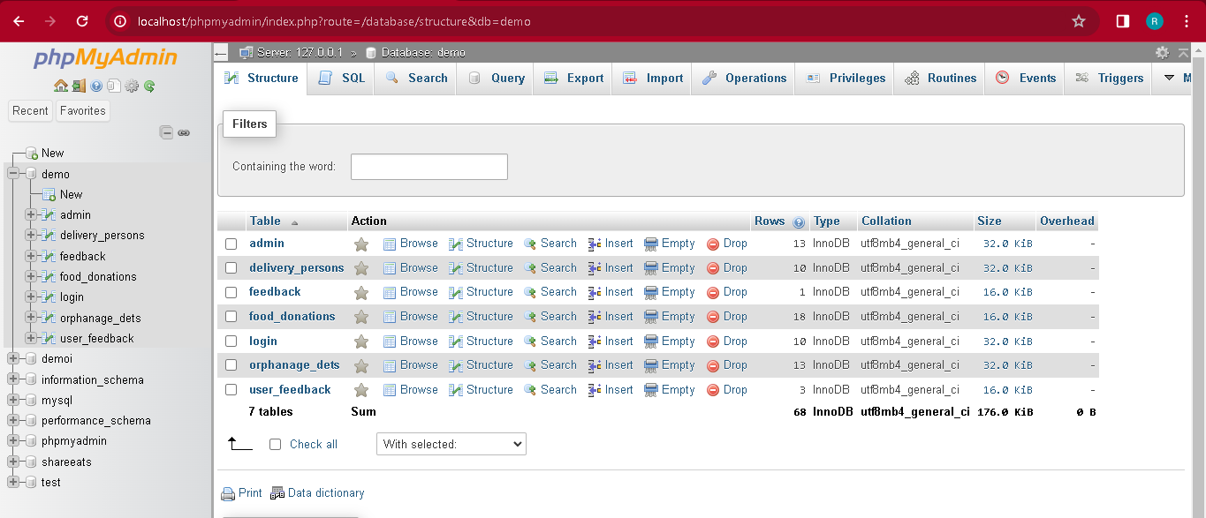

Figure 3.9 Database

**3.5 TABLE STRUCTURE**

**3.5.1 TABLE NAME:DONOR**

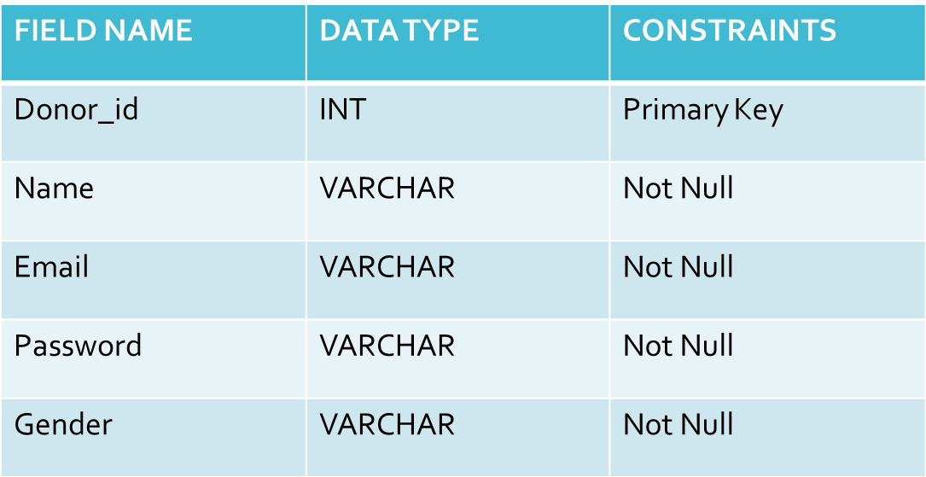

**3.5.2 TABLE NAME:ADMIN**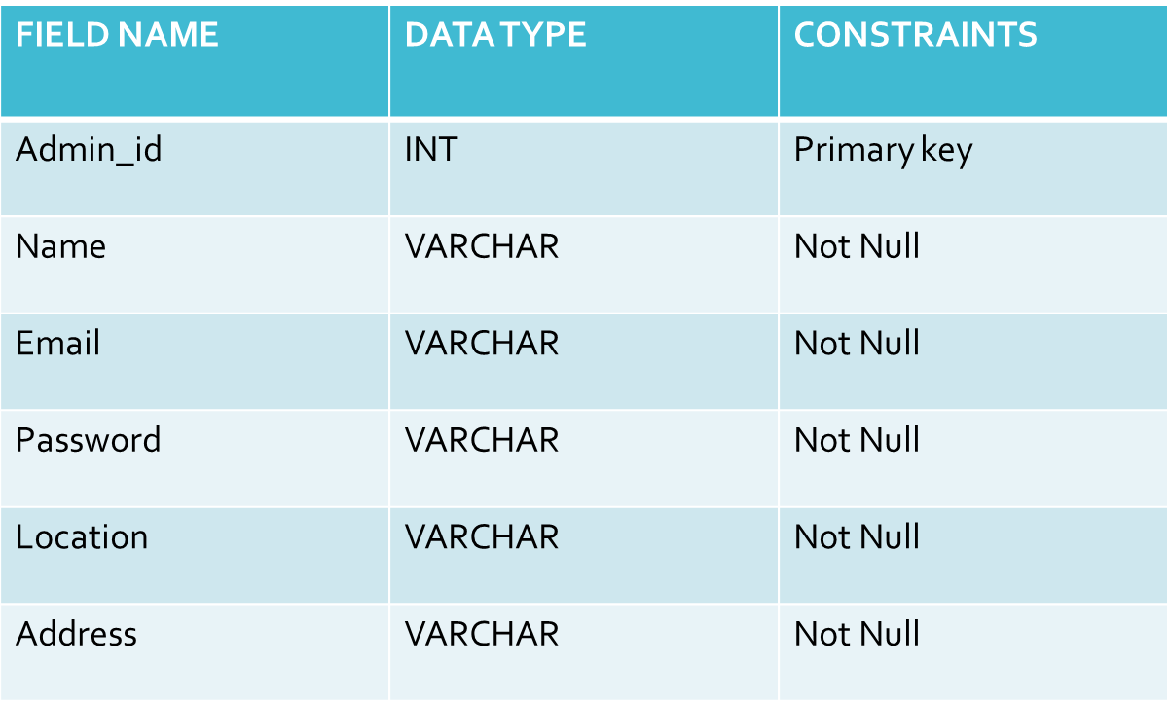

**3.5.3 TABLE NAME:AGENT**

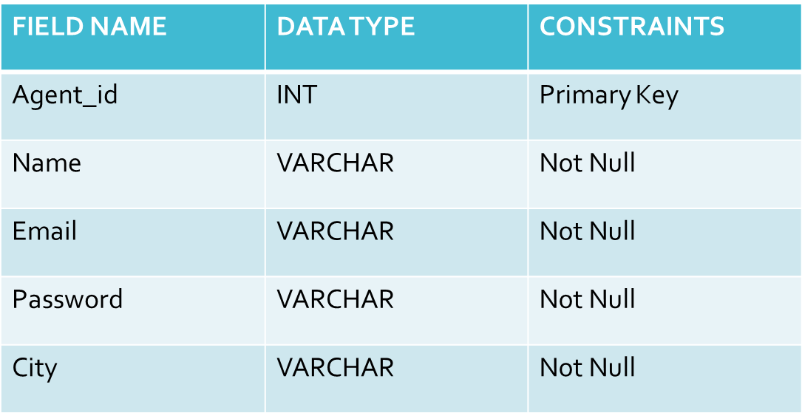

**3.5.4 TABLE NAME:FOOD DONATION**

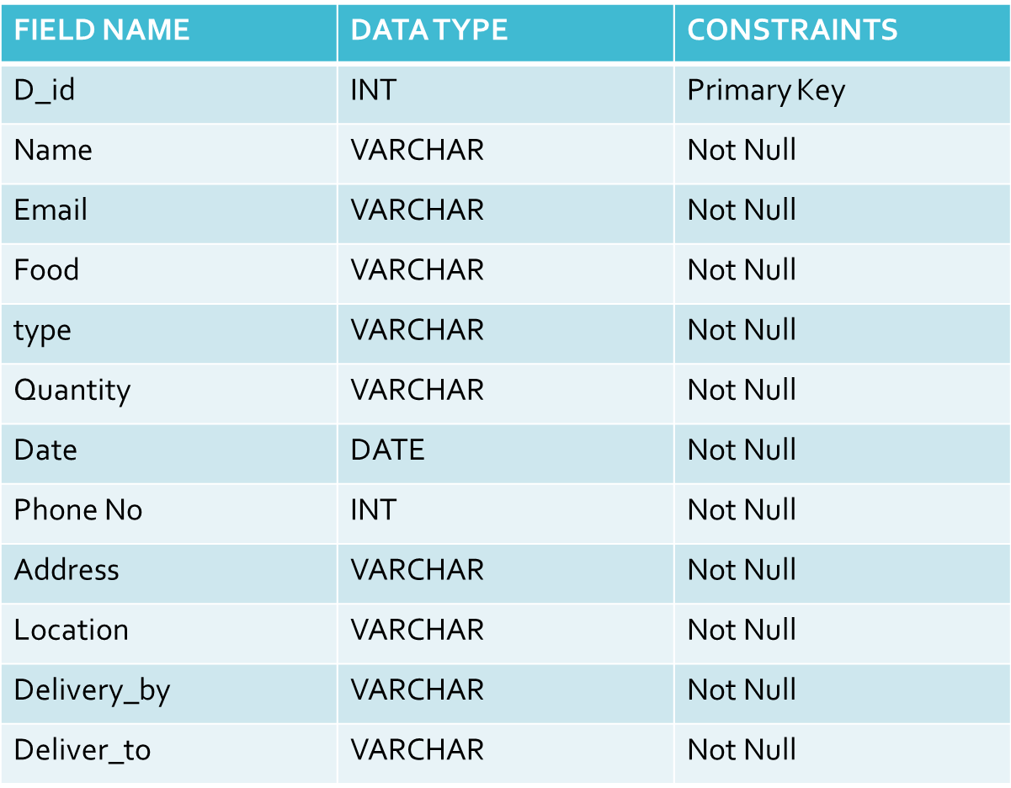

**3.5.5** **TABLE NAME:FEEDBACK**

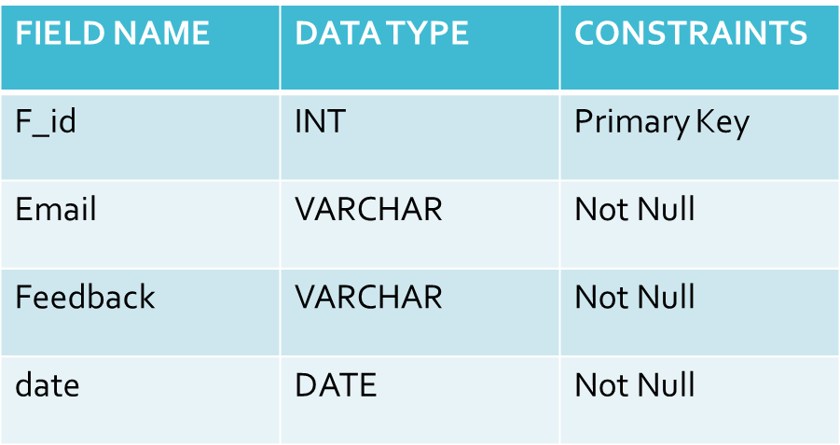

**3.5.6 TABLE NAME:ORPHANAGE DETAILS**

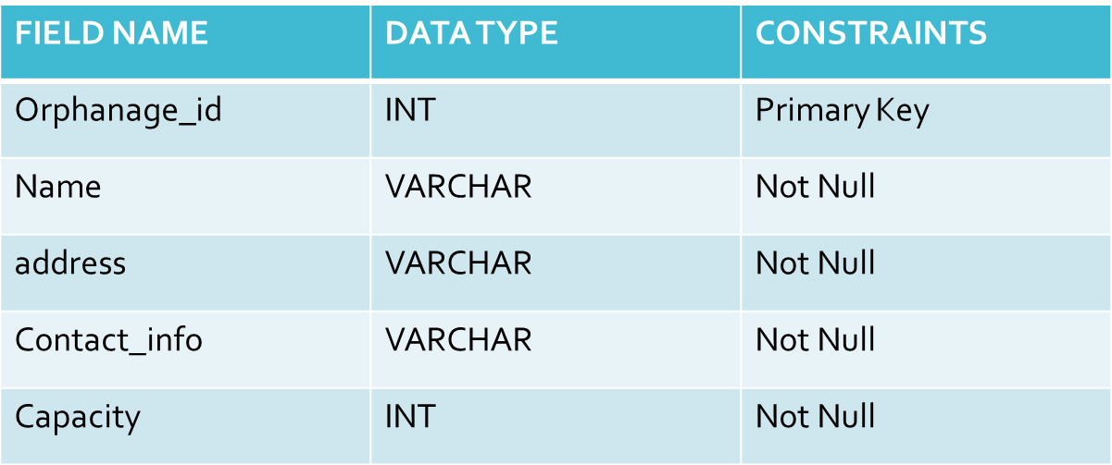

**CHAPTER**-**4**

**SYSTEM TESTING**

**4.1 INTRODUCTION**

System testing is a crucial phase in the software development life cycle, ensuring that the entire integrated system functions as intended and meets specified requirements. This testing phase evaluates the system's compliance with design specifications, user expectations, and overall performance standards. It involves systematically examining each component and their interactions to identify and rectify any defects or discrepancies. System testing aims to validate the system's functionality, reliability, and performance under various conditions, ensuring that it is ready for deployment. This phase is essential for guaranteeing a robust and error-free system, ultimately contributing to the delivery of a high-quality software product.

**4.1.1 UNIT TESTING**

Unit testing is a fundamental phase in software development where individual components or units of a system are scrutinized in isolation to ensure they function as intended. It involves testing code at the smallest functional level, typically individual functions or methods, to validate their correctness. During unit testing, developers write test cases that target specific aspects of the code, checking for errors, and verifying expected behaviors. The primary goal is to identify and rectify defects early in the development process, contributing to the overall reliability and stability of the software. Unit testing plays a critical role in maintaining code quality and facilitating a more efficient and robust development workflow.

**4.1.2 INTEGRATION TESTING**

Integration testing is a pivotal phase in the software development lifecycle where different modules or components of a system are combined and tested as a group. The primary objective is to ensure that these integrated elements function seamlessly together, detecting and addressing any issues that may arise at the interfaces between them. Integration testing helps validate the correct flow of data, control, and functionality across interconnected modules, enhancing the overall reliability and performance of the software. By identifying and resolving integration issues early in the development process, this testing phase contributes to the creation of a cohesive and well-functioning software system.

**4.1.3 USER ACCEPTANCE TESTING**

User Acceptance Testing (UAT) is the final phase of the software testing process where end-users evaluate the system to determine if it meets their requirements and expectations. This testing phase ensures that the software aligns with real-world scenarios and user needs before its deployment. During UAT, users perform various test cases and provide feedback on the system's functionality, usability, and overall performance. Successful UAT is a critical milestone, indicating that the software is ready for production and has gained approval from its intended users. This phase is essential for ensuring that the software not only meets technical specifications but also fulfills the practical needs and preferences of the end-users.

**4.2 TEST CASES**

The test cases for the Food Donation Management System encompass various critical aspects of its functionality. These include validating the donor registration process, ensuring accurate food donation entries, confirming seamless agent assignments, and verifying successful pickups and deliveries. The administrator dashboard is rigorously tested to guarantee effective management of donation and delivery details, while the notification system is examined to ensure timely alerts for donors and administrators. Security measures are assessed, including password encryption and protection against common vulnerabilities. The user interface undergoes scrutiny for responsiveness and consistency across devices, and reporting functionalities are tested to generate accurate and meaningful data. Finally, integration testing ensures the system's seamless interaction with external APIs or databases. These test cases collectively contribute to the robustness, security, and user-friendliness of the Food Donation Management System.

**CHAPTER-5**

**SYSTEM IMPLEMENTATION**

**5.1 IMPLEMENTATION METHOD**

The implementation of the Food Donation Management System involves a systematic and collaborative approach. Starting with thorough requirements gathering from stakeholders, including donors, administrators, and distribution agents, the project proceeds to the design phase. The comprehensive system design encompasses architecture, database schema, and user interfaces for various modules such as donors, administrators, and agents. A careful selection of technology stack, including programming languages and databases, is made to ensure scalability and security. The backend development includes the creation of logic for user authentication, donation submissions, and agent assignments, while frontend development focuses on intuitive interfaces. Integration with external services, rigorous testing, deployment, and user training follow suit. Ongoing monitoring, maintenance, and user feedback collection ensure the system remains robust and adaptable. This iterative process ensures the successful implementation of the Food Donation Management System, meeting the needs of all stakeholders and contributing to effective surplus food distribution.

**5.2 IMPLEMENTATION PLAN**

The implementation plan for the Food Donation Management System involves a systematic and phased approach to ensure a successful development and deployment process. It commences with project initiation, where project goals are defined, and a dedicated team is assembled. Requirements are thoroughly analyzed, and the system design is conceptualized, encompassing architecture, database schema, and user interfaces. The technology stack is carefully selected, and the backend and frontend development phases follow suit, implementing key functionalities and ensuring a seamless user experience. External services are integrated to enhance system capabilities. Rigorous testing, including unit testing, integration testing, and user acceptance testing, is conducted to guarantee system reliability. Deployment to staging and production environments is meticulously executed, followed by user training and comprehensive documentation. Ongoing monitoring tools are implemented for performance evaluation, and a maintenance plan is established for future updates. Feedback from users is actively sought for iterative improvements, and the project concludes with a thorough evaluation of success and the closure of project documentation. This methodical plan ensures the efficient and effective implementation of the Food Donation Management System, aligning with stakeholder needs and promoting streamlined surplus food distribution.

**CHAPTER**-**6**

**OUTPUT SCREENSHOTS**

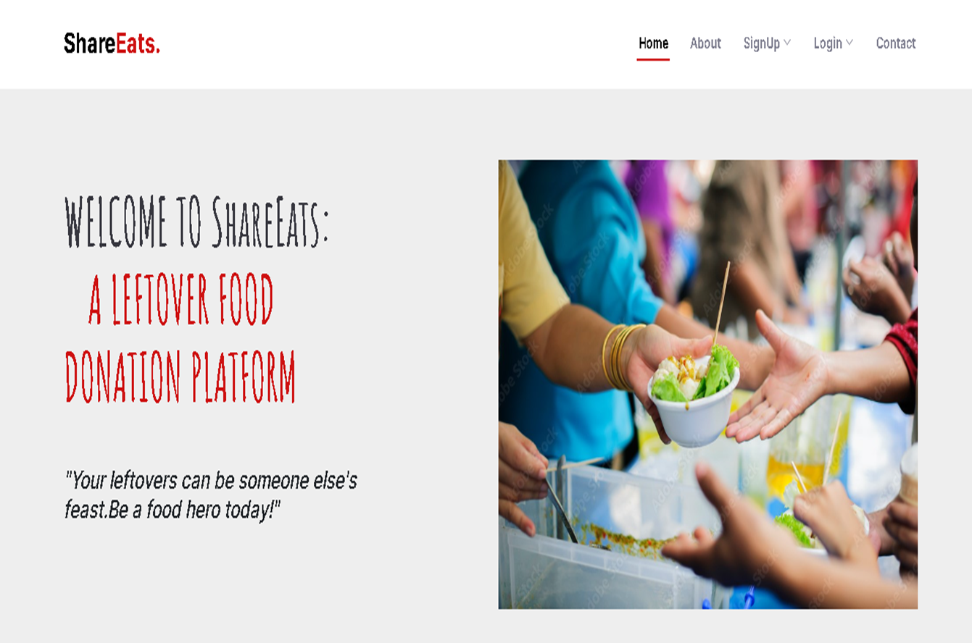

Figure 4.1 Home page

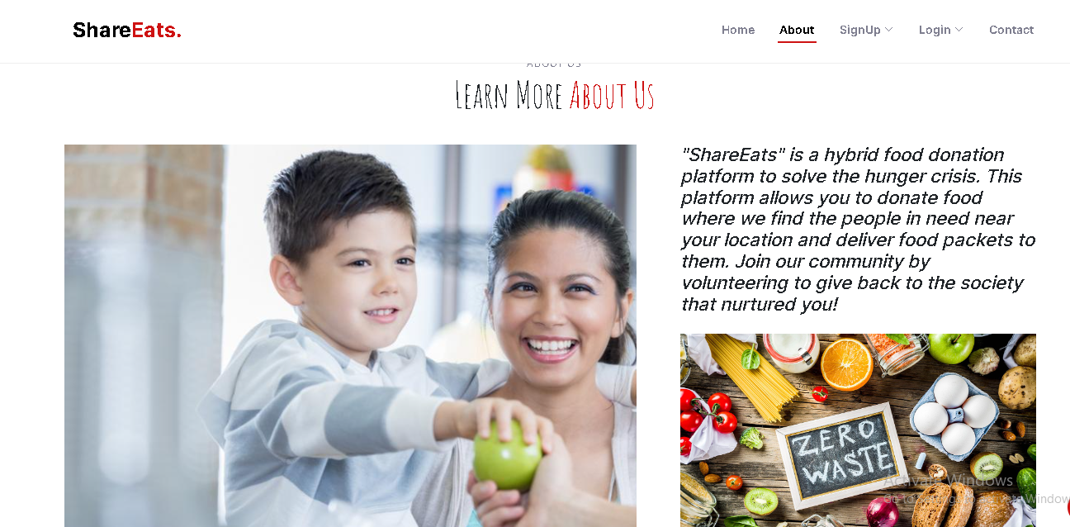

Figure 4.2 About page

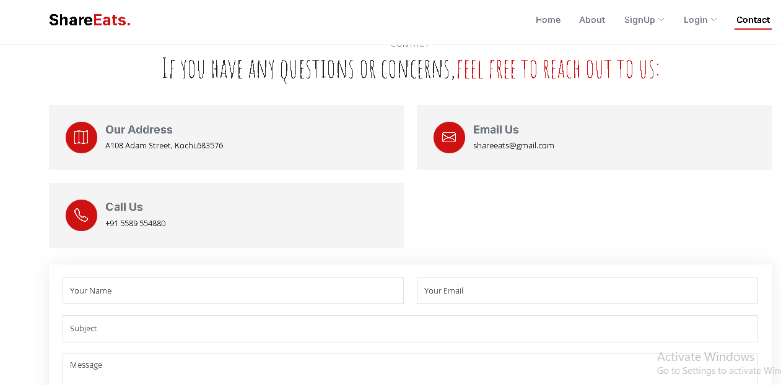

Figure 4.3 Contact page

**ADMIN:**

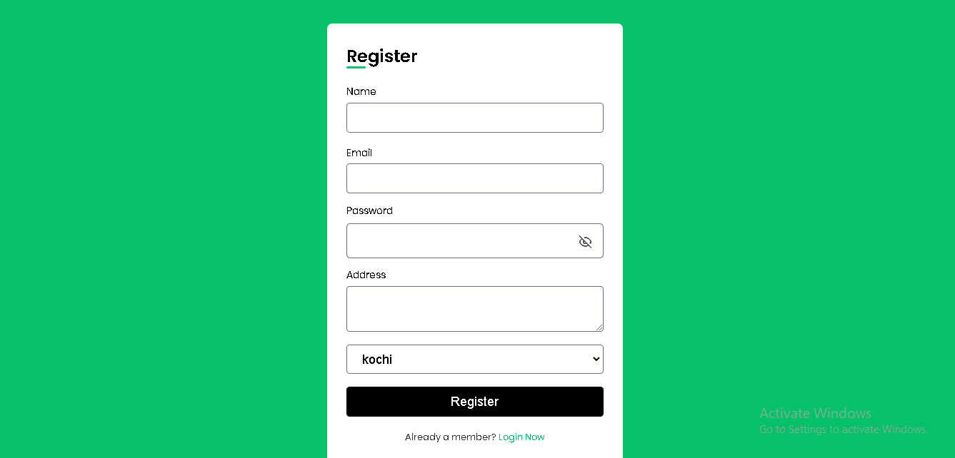

Figure 4.4 Admin registration

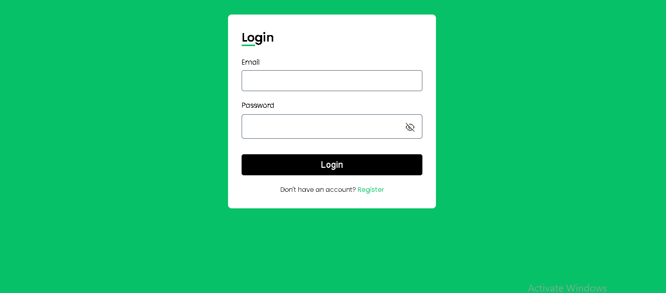

Figure 4.5 Admin login

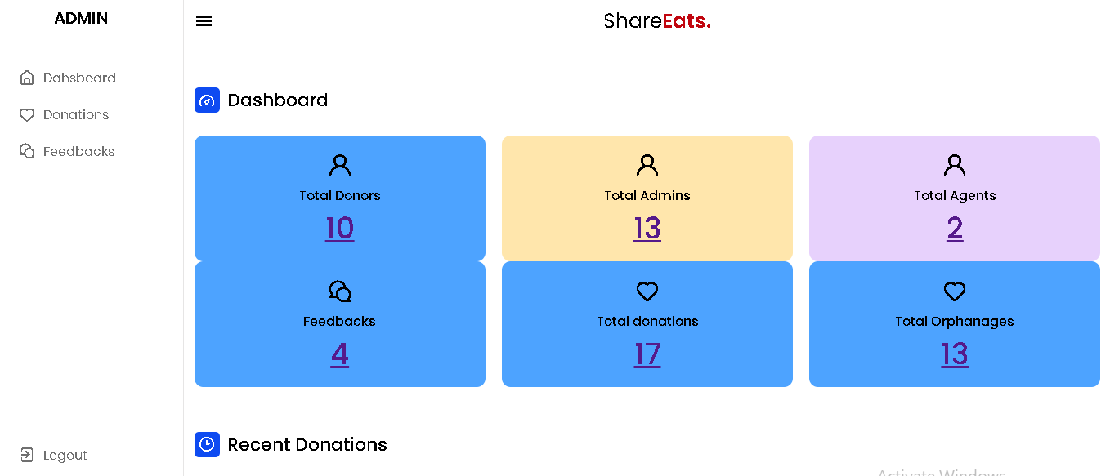

Figure 4.6 Admin dashboard

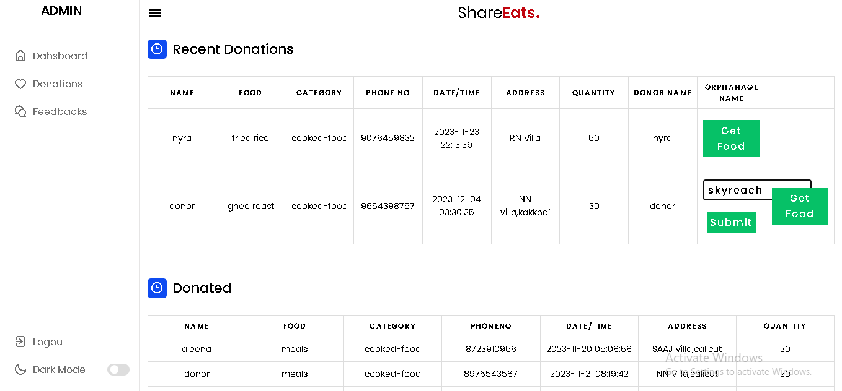

Figure 4.7 Recent donations and donated

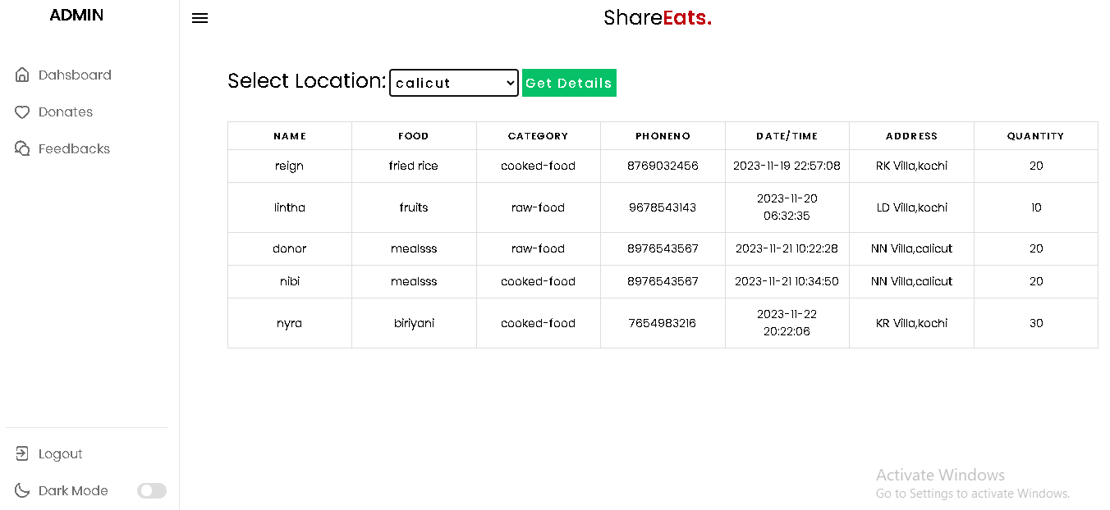

Figure 4.8 Donation details(city wise)

**DONOR:**

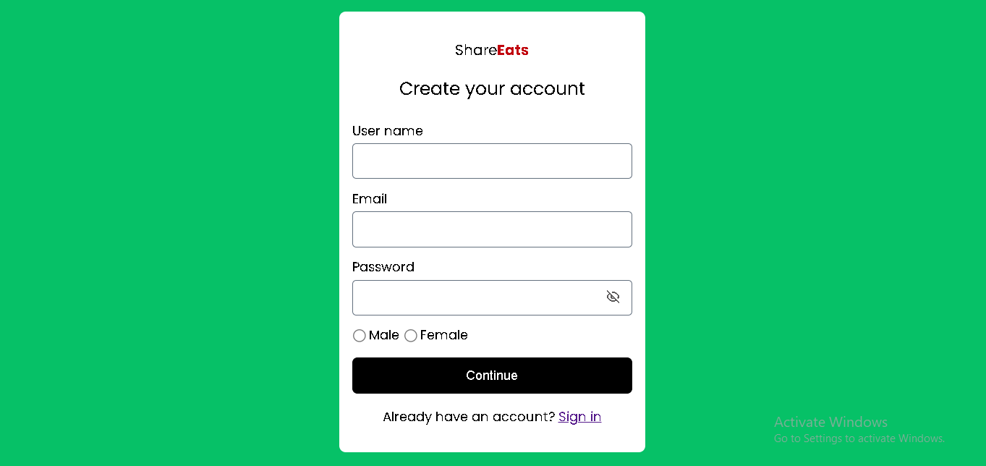

Figure 4.9 Donor registration



Figure 4.10 Donor home page

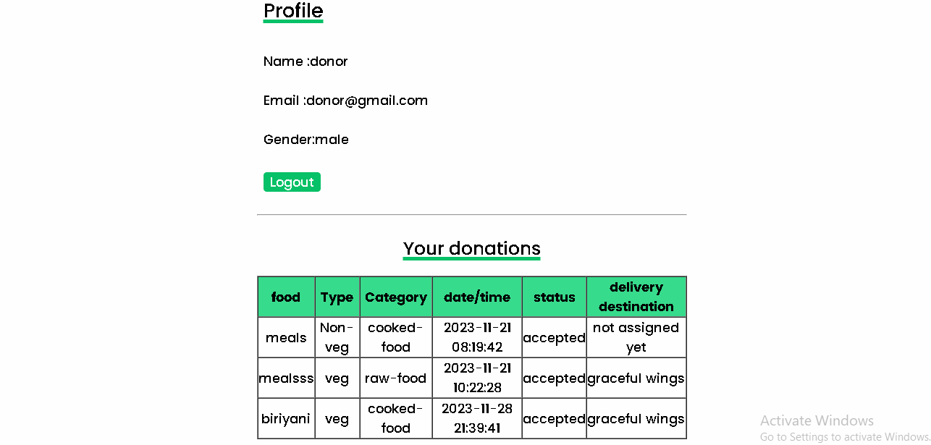

Figure 4.11 Donor profile

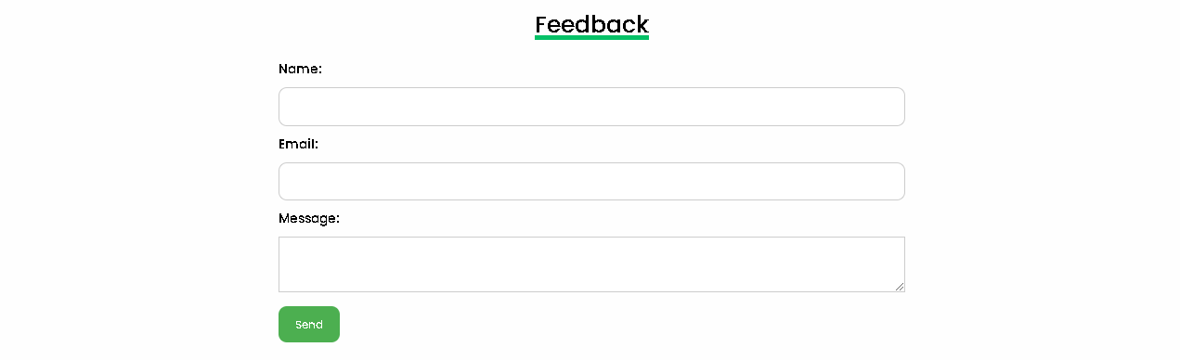

Figure 4.12 Feedback

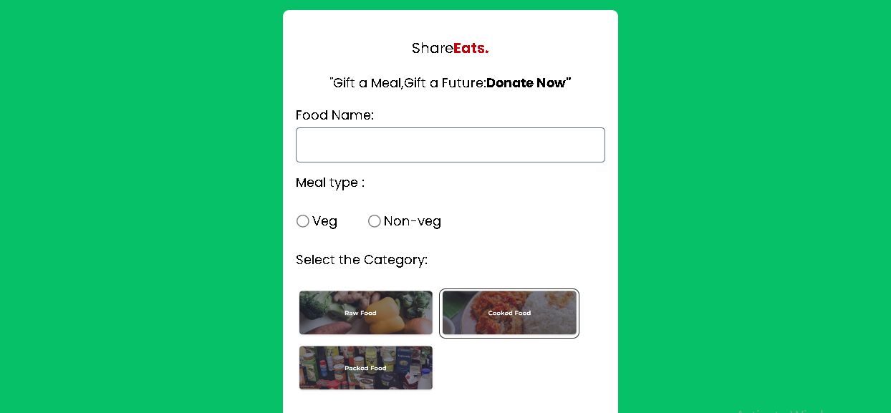

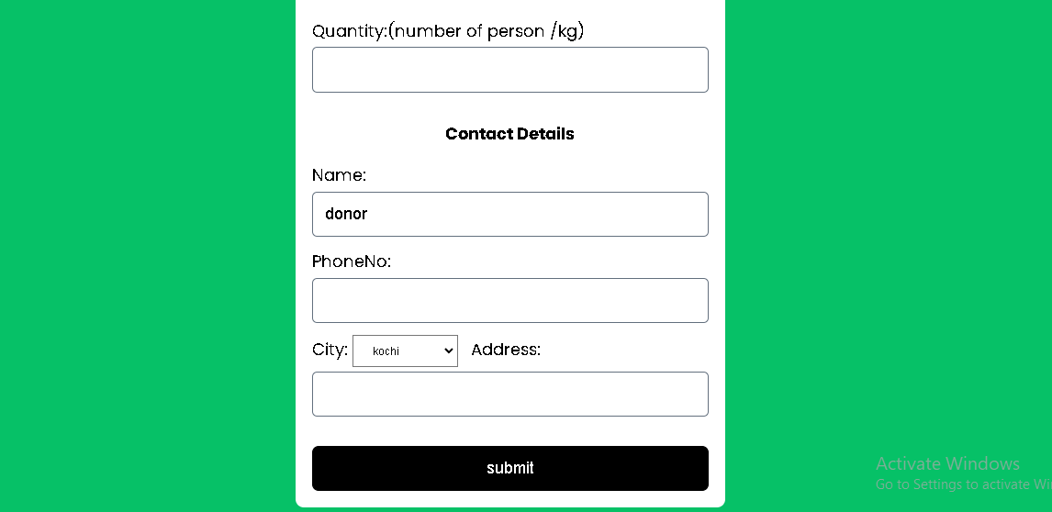

Figure 4.13 Food donation

**AGENT:**

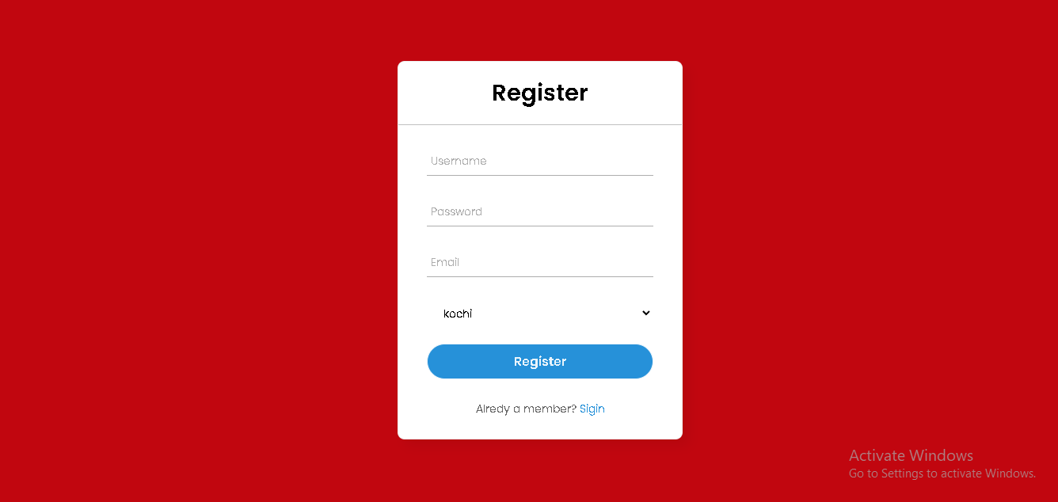

Figure 4.14 Agent registration

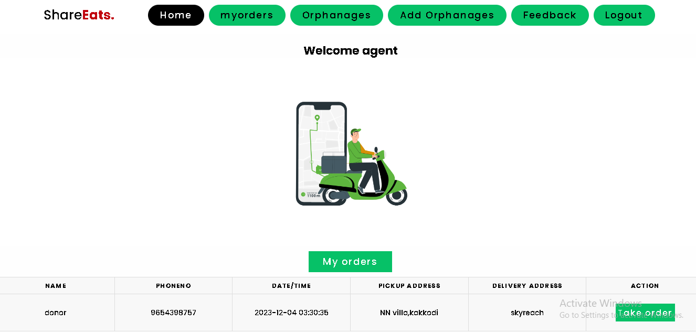

Figure 4.15 Agent home page

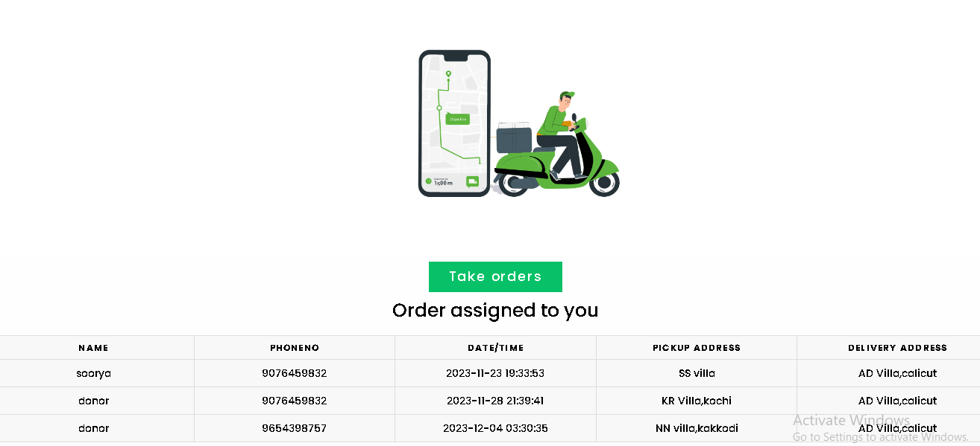

Figure 4.16 Agent orders

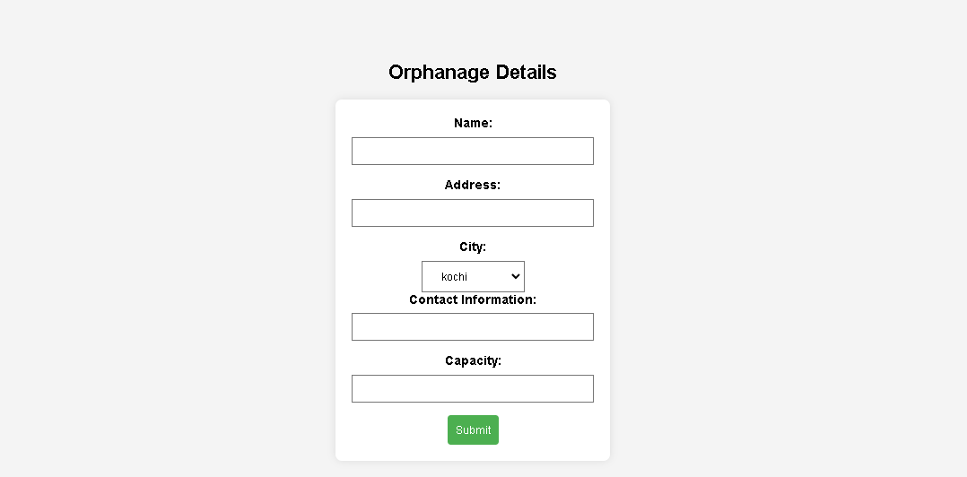

Figure 4.17 Add orphanages

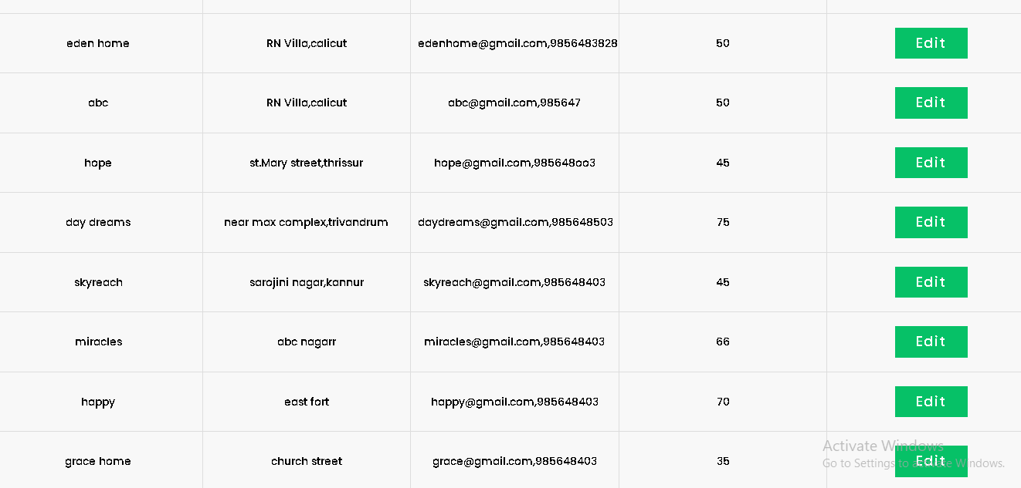

Figure 4.18 Orphanage details

**CHAPTER**-**7**

**CONCLUSION AND FUTURE SCOPE**

The Food Donation Management System project has successfully addressed the critical issue of surplus food distribution, streamlining the process through an innovative web-based platform. The system efficiently connects donors, administrators, and distribution agents, reducing food wastage and contributing to social welfare. Real-time communication, intuitive interfaces, and secure data handling have enhanced the overall effectiveness of surplus food management. The positive impact is evident in improved coordination, immediate donor feedback, and optimized logistics**.**

The project lays the foundation for future enhancements and expansion. Integration with emerging technologies such as machine learning can enhance predictive analytics for better demand forecasting. Mobile applications can broaden accessibility and user engagement. Collaborations with more stakeholders, including businesses and local communities, can amplify the system's reach. Continuous refinement based on user feedback and evolving technology trends will ensure the Food Donation Management System remains adaptable and impactful in addressing food wastage and promoting social responsibility.

**REFERENCES**

1. H. Raut, S. Rajput and D. Nalavade, “Smartphone based food supply chain for Aurangabad city using GIS Location Based and google web services”.
2. Ciaght and A. Villafiorita, “Beyond food sharing: supporting food wastage reduction using ICT”
3. K. Raut, N. Shah and A. Thorat, “Food Donation Portal”.
4. D. Shah, A. Ansari and R. Sharma, “Helping Hands”.
5. D. Jethwa, A. Agrawal, R. Kulkarni and L. Raut, ”Food waste reduction through donation”, International Journal of Recent Trends in Engineering & Research (IJRTER) Volume 04, Issue 03, March 2018
6. <https://www.samaa.tv/opinion/2017/12/food-waste-newwar-fight/>
7. https://foodtank.com/news/2018/09/apps-preventingfood-waste/